“not valid DNS1” error message on Wanscam and Sricam Security Cameras

Error setting a **fixed address** on your new Wanscam or Sricam Security Camera you get a “not valid DNS1” error using Google Chrome or Miscrosoft Internet Explorer.

It appears the html delivery from the camera has a bug in it for a particular variable.

1. Connect to the camera using the chrome browser and login.
2. Select the “Setup” screen (wrenchs at bottom of main screen).
3. Select “Basic Network Settings”
4. Deselect “Obtain IP from DHCP Server”.
5. Make modifications to screen you want to submit
6. if you get the “not valid DNS1” error:
7. Select the entire Web Page (all) Using Control + A (Ctrl/A).
8. RIGHT click a highlighted are and select “Inspect”
9. Scroll in the bottom windows until you see

<tr id=“tr_dns1” style=”display:none”

10. Select this line (click on it).

11. Click on “display:none” to highlight it.

12. Change “display:none” to “display: table-row;” using

left and right arrow keys and “backspace key”.

13. Press “Enter to implement your modification”

14. When change is made click on the “Submit” button in the

upper windows. The “Submit” should work at this time.

ERROR MESSAGE:

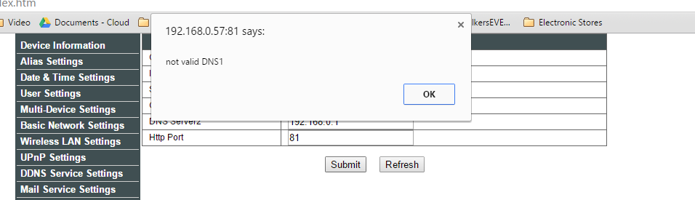

MAIN SCREEN - CLICK WRENCHES AT BOTTOM FOR SETUP

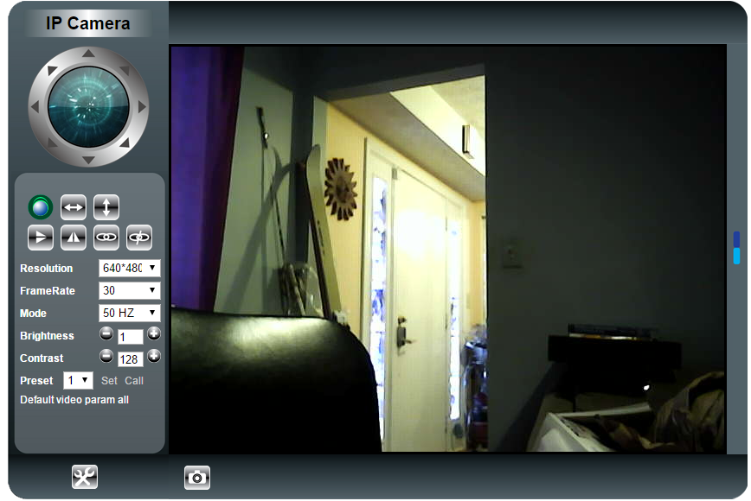

DESELECT “Obtain IP from DHCP Server”.

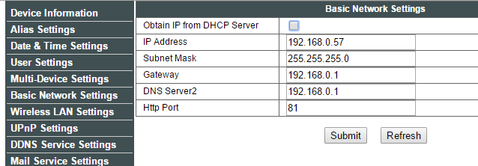

“ALL” selected, Next select “Inspect”

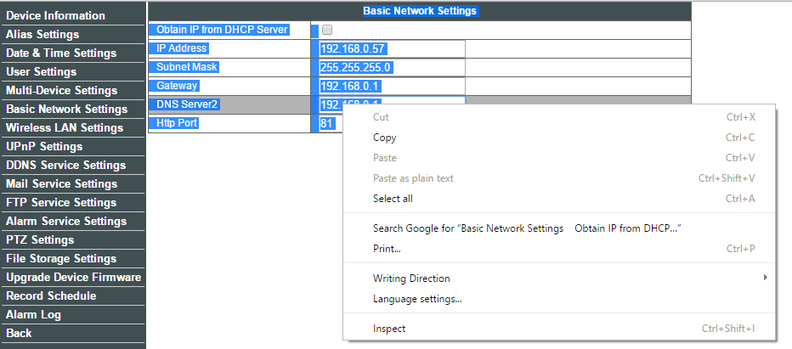

INSPECT SCREEN - WITH CORRECT LINE SELECTED

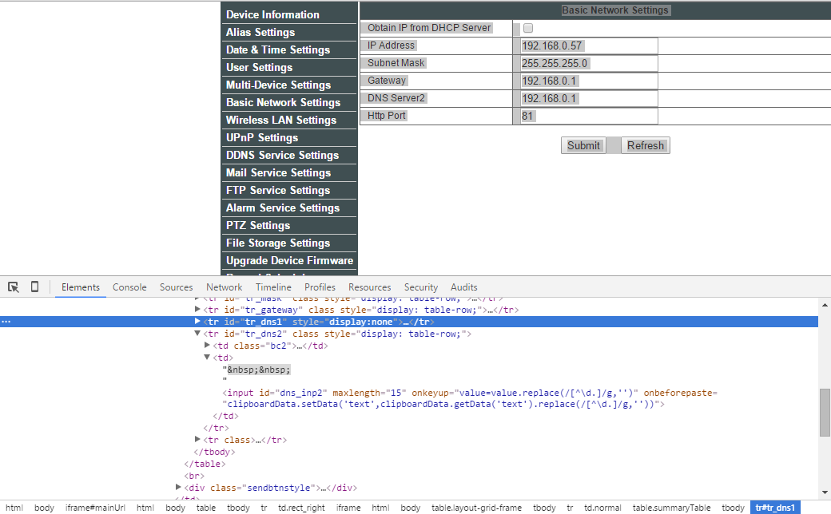

INSPECT SCREEN - WITH CORRECT VALUE SELECTED

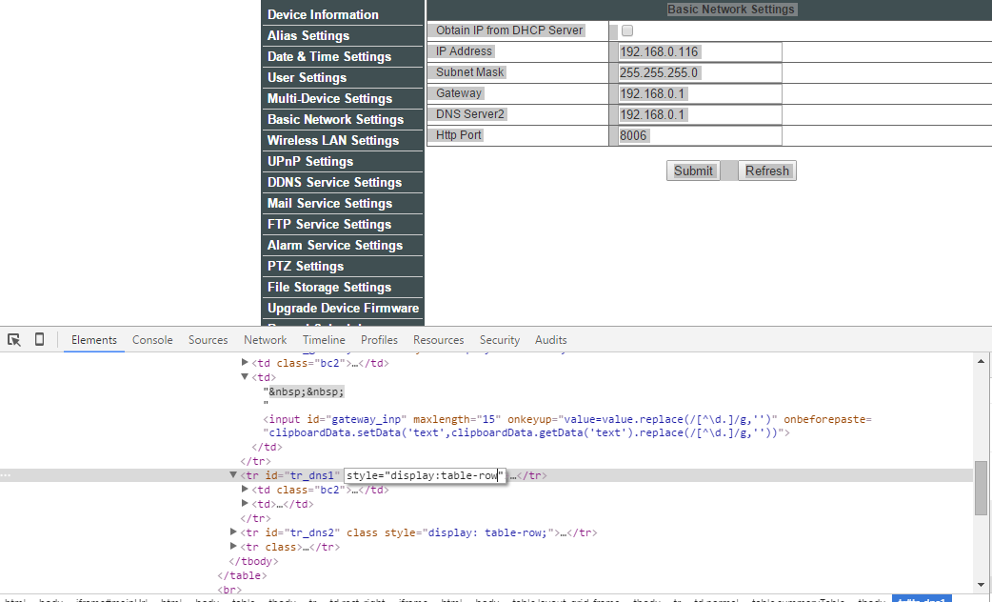

INSPECT SCREEN - AFTER EDITS ARE COMPLETED:

PRESS “Enter” and select “Submit” from top window.

